- AC CIRCUITS

  - AC VOLTAGE AND CURRENT – CALCULATIONS

    - OBJECTIVE

To study sinusoidal voltages and currents in order to understand frequency, period, effective value, instantaneous power and average power.

    - DISCUSSION

Alternating Current (AC) is the world standard for driving motors and other electrical equipment. As the name implies, an alternating current continually and periodically changes direction, going first one way and then reversing. One may consider an alternating current to be a DC current, which is constantly, and periodically changing amplitude and direction. The time necessary for the current to undergo one complete change of amplitude and direction is called a cycle. The number of cycles which occur in one second is called the frequency, which is measured in Hertz (cycles per second). In North America, AC system frequency is standardized at 60 Hertz. Much of the remaining world has chosen a 50 Hz standard.

Alternating voltages also reverse polarity in a periodic manner with continually changing amplitude. The shape of the voltage waveform is dependent upon the manner in which it is produced. One may construct a device that produces voltage waveforms which are square waves, triangular waves, etc. However, one type of waveform is most suitable to the use of electric power in transformers and electric motors, the sine wave. Pure sinusoidal waveforms of a single frequency minimize mechanical and electrical losses in transformers and motors, thus allowing for the highest efficiency of energy conversion. If one considers the Fourier Transform of a triangular wave or square wave, which consist of a large number of sinusoidal waveforms at many frequencies, it becomes clear that there is increased potential for detrimental effects such as mechanical resonance, eddy currents, sequence currents, etc. A pure sine wave undergoing electrical transformation (either integral or derivative) remains a pure sinusoid, minimizing losses. Another advantage of sine wave voltages is that the resulting current waveforms are also sinusoidal. This is not necessarily true of other waveform shapes. Having consistent wave shapes reduces the burden of power calculations and the analysis of electric systems.

    - INSTRUMENTS AND COMPONENTS

(None)

    - PROCEDURE

- Consider the ideal AC generator pictured below. Assume it produces a sinusoidal voltage output waveform between terminals A and B.

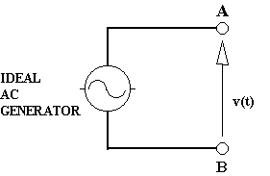

- Let the voltage waveform have a peak value of 100 volts, such that the algebraic description is v(t) = 100 sin (ωt) volts. Calculate the value of v(t) at 15 degree intervals (i.e. when ωt = 0°, 15°, 30°, …, 330°, 360°) and plot them on the graph provided (also, write them down, since you will need these values again). Connect the plotted points with a smooth curve and label it v(t). Remember that the waveform will have a negative value for half its period.

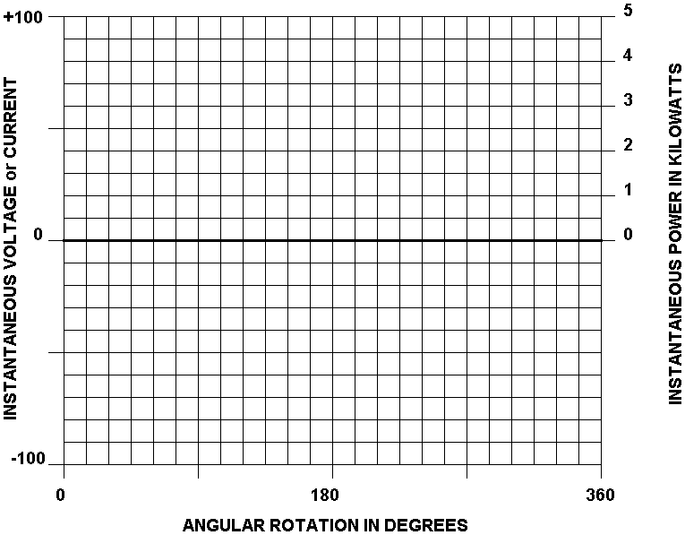

- Read the instantaneous value of v(t) from the graph for each of the following values of ωt and record it below:

ωt in Degrees | v(t) in Volts
80° | volts
160° | volts
250° | volts
350° | volts

- If a load resistance of 2 Ohms is connected across terminals A and B, a current, i(t), will flow. Knowing the instantaneous value of the voltage from the graph and using Ohm’s Law [ i(t) = v(t)/R ], calculate and record the instantaneous values of i(t) for the following values of ωt:

ωt in Degrees | i(t) in Amps | ωt in Degrees | i(t) in Amps
30° | amps | 210° | amps
60° | amps | 240° | amps
90° | amps | 270° | amps
120° | amps | 300° | amps
150° | amps | 330° | amps
180° | amps | 360° (0°) | amps

- Plot the instantaneous current values recorded above on the same graph with v(t) and draw a smooth curve through the plotted points. Label this curve i(t).

- Knowing that the instantaneous power, p(t), is the product of the instantaneous voltage and current, calculate p(t) at every 30 degree interval:

ωt in Degrees | p(t) = v(t) x i(t) | ωt in Degrees | p(t) = v(t) x i(t)
30° | watts | 210° | watts
60° | watts | 240° | watts
90° | watts | 270° | watts
120° | watts | 300° | watts
150° | watts | 330° | watts
180° | watts | 360° (0°) | watts

- Plot the instantaneous power values on the same graph with v(t) and i(t), then draw a smooth curve through the plotted points. Label this curve p(t).

- Examine the power curve and determine the maximum, or peak, instantaneous power dissipated by the resistor and the minimum value of instantaneous power. Also make your best estimate as to the average power dissipated by the resistor.

Maximum (peak) p(t) | Minimum p(t) | Average Power
Watts | Watts | Watts

- It can be shown mathematically that the average power will equal exactly one-half the peak instantaneous power. The average power is equivalent to that supplied to the two ohm resistor from a DC source. If 2500 Watts were dissipated by a 2 Ohm resistor, supplied by a DC source, what would the DC Voltage of the supply be? (Use the equation, P = V²/R)

____________________________________________________________ Volts, DC

10) What is the DC current supplied by the source for those conditions? (Use Ohm’s Law)

____________________________________________________________ Amps, DC

Note that the AC values of 100 Volts, peak and 50 Amps, peak deliver the same average power as DC values of 70.7 Volts, DC and 35.4 Amps, DC. This is a ratio of one over the square root of two (1/√2). Thus, the effective value of an AC signal is its peak value divided by the square root of two. This is known mathematically as the root-mean-square or RMS value of the waveform, and leads to the following equations:

Vrms = 0.707 Vpeak

Irms = 0.707 Ipeak

    - CONCLUSIONS

- How long does it take, in seconds, for the voltage to change from 0 to maximum (peak) value on a 60 Hz power system?

_________________________________________________________________ seconds

- What is the length of time of the positive portion of one complete cycle of a 60 Hz current waveform?

_________________________________________________________________ seconds

- In a 50 Hz system, what is the time duration of one complete cycle?

_________________________________________________________________ seconds

- If standard residential wiring is rated at 120 Volts, rms, what is its peak value?

_________________________________________________________________ Volts

- An incandescent lamp rated at 100 Watts, emits a certain amount of illumination when energized at 120 Vrms. Would the amount of illumination increase, decrease or remain the same when the lamp is energized at 120 Vdc? Explain.

______________________________________________________________________

______________________________________________________________________

- Explain in your own words what is meant by the terms effective voltage and effective current:

______________________________________________________________________

______________________________________________________________________

______________________________________________________________________

______________________________________________________________________

  - AC VOLTAGE AND CURRENT – MEASUREMENTS

    - OBJECTIVE

To measure the effective value of alternating waveforms, learn the use of AC ammeters and voltmeters, and verify Ohm’s Law for AC circuits.

    - DISCUSSION

The effective value of any AC signal is defined by the amount of useable energy it delivers to a load. The useable energy is usually quantified as the amount of heat energy dissipated by a resistor. For example, to measure the effective value of an AC voltage, one might measure the temperature of a resistor connected across the voltage. If the resistor is then connected across a variable DC voltage source whose voltage level is raised until the resistor temperature is equal to the temperature measured during AC excitation, the DC voltage value is equal to the effective value of the AC voltage signal.

Heat energy is not the only parameter by which the effective value of AC signals may be quantified, however. One can also use an incandescent lamp. The brightness of the lamp is a reasonably accurate indicator of the power dissipated by the lamp (i.e. the brighter the lamp, the more power it is dissipating). In this experiment, such a method is exploited for determining the effective value of AC voltages by comparing the brightness of a lamp excited by an AC signal to the brightness of a lamp excited by a DC source. Fortunately, instruments have also been designed that determine the effective values of AC signals with much greater speed and accuracy.

    - INSTRUMENTS AND COMPONENTS

Power Supply Module EMS 8821
Resistance Module EMS 8311
AC Metering Module (2.5 A) EMS 8425
AC Metering Module (250 V) EMS 8426
DC Metering Module EMS 8412
Synchronizing Switch Module EMS 8621

    - PROCEDURE

CAUTION! – High voltages are present in this Experiment. DO NOT make any connections with the power supply ON. Get in the habit of turning OFF the power supply after every measurement.

- Examine the Synchronizing Switch Module, EMS 8621, paying particular attention to the circuit schematic on the face plate. Note that the module is divided into three sections, each containing an incandescent lamp connected between two numbered terminals. Also note that in parallel with each lamp is a circuit breaker and a switch. The three switches are ‘ganged’ together, which is to say that all three switches are opened and closed simultaneously by the movement of the toggle lever on the face plate. Place the toggle switch in the ‘0’ (Open) position and leave it there for the remainder of this experiment.

- Using the Power Supply, Synchronizing Switch, AC Metering and DC metering Modules connect the circuit shown below. Note that the fixed 120 Volt AC source is connected across one lamp and the variable DC source is connected across the adjacent lamp.

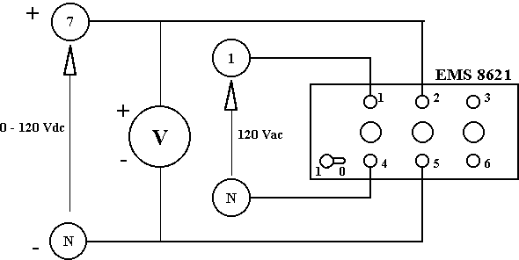 | Vac = 120 V rms  Vdc = _________ Volts dc

- Turn on the power supply. The lamp excited by the fixed AC source will glow. Now vary the DC voltage level by turning the voltage control knob in a clockwise direction until both lamps glow with equal intensity (dimming the lights in the lab will make this easier). Measure and record the value of the DC voltage.

Because the two lamps are glowing with equal intensity, they are each dissipating approximately the same power. Thus the measured DC voltage is a good indicator of the effective value of the 120 V, AC signal.

- Return the voltage control knob to zero percent and turn OFF the power supply.

- Now connect the circuit shown below using the Resistance Module, EMS 8311, set for 57 Ohms. (To get 57 Ohms, connect all 3 columns of 3 resistors in parallel, with all resistors in each column switched on)

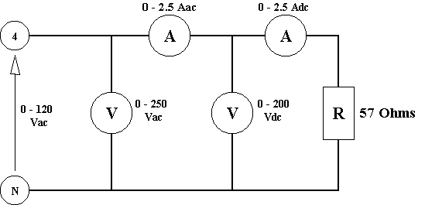 | Vac = _______ Vac  Iac = _______ Aac  Vdc = _______ Vdc  Idc = _______ Adc

- Turn on the power supply and turn the voltage control clockwise until the AC voltmeter reads exactly 120 V rms. Measure and record the AC and DC voltages and currents. (Note that even though an effective AC voltage and current are present, the DC instruments read zero.)

- Return the voltage control knob to zero percent and turn OFF the power supply.

- Connect the following circuit. Wire the resistance module so that the resistance is 57 Ohms as in the previous experiment. (You will also be required to change the resistance value to 100 Ohms.)

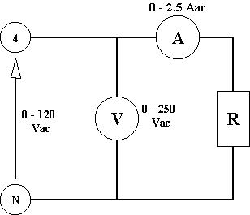

- Turn on the power supply and adjust the voltage control until the AC voltmeter reads 100 V rms.

- Measure Iac for R equal to 57 Ohms. Turn OFF the power supply and rewire the resistance module for 100 Ohms. Turn ON the power supply and measure Iac for the 100 Ohm circuit. Record the values on the table below.

- Increase the voltage control until the AC voltmeter reads 120 V rms. Measure the value of Iac for the 100 Ohm resistance at 120 V rms. Turn OFF the power supply and rewire the resistance module for 57 Ohms. Turn ON the power supply and measure Iac for the 57 Ohm circuit at 120 V rms. Record the values below.

- Return the voltage control knob to zero percent and turn OFF the power supply.

V ac : | 100 V rms |  | 120 V rms
Resistance : | 57 Ohms | 100 Ohms | 57 Ohms | 100 Ohms
Iac :
V / I :
V x I :

- Calculate the resistance for each measurement using Vac and Iac and Ohm’s law. Record the results in the row marked V / I.

- Calculate the power dissipated by the resistor in each configuration and record the results in the row marked V x I.

- Do the results support or disprove Ohm’s law with respect to AC circuits?

____________________________________________

    - CONCLUSIONS

- What might be the explanation for zero readings on the DC ammeter and voltmeter when measuring AC signals?

______________________________________________________________________

______________________________________________________________________

______________________________________________________________________

______________________________________________________________________

- Explain why most AC voltmeters and ammeters are designed to display the effective, or rms, value of the AC waveform:

______________________________________________________________________

______________________________________________________________________

______________________________________________________________________

______________________________________________________________________

- If an AC distribution system operates at 600 Volts, AC, what is the peak value of the voltage?

______________________________________________________________________

______________________________________________________________________

- A 60 watt incandescent lamp is operated at 120 V rms. Calculate the AC current and the ‘hot’ resistance of the lamp:

______________________________________________________________________

______________________________________________________________________

______________________________________________________________________

______________________________________________________________________

  - WATTMETERS

    - OBJECTIVE

To study the use of a Wattmeter and become familiar with real and apparent power in AC circuits.

    - DISCUSSION

In DC circuits the power supplied to a resistive load is always equal to the product of the voltage and current. In AC circuits that is not necessarily the case, even when using RMS (or effective) values of voltage and current. Impedance elements in AC circuits are not limited to resistances, but include reactive elements such as the capacitor and inductor. Reactive elements do not consume real power as a resistor does. Instead they absorb or produce reactive power and in the process change the voltage and current waveforms in the circuit. For this reason, wattmeters are an essential tool in the analysis of AC circuits.

Apparent Power (measured in volt-amperes, VA) is defined as the product of the rms AC voltage and rms AC current. Apparent power (VA) is only equal to real power (Watts) when the load circuit is purely resistive, as in the previous laboratory experiments. Load circuits that are not purely resistive will have an apparent power significantly different from real power. A refrigerator is an example of a load which absorbs a large quantity of reactive power.

    - INSTRUMENTS AND COMPONENTS

Power Supply Module (0 – 120 Vac) EMS 8821
Resistance Module EMS 8311
Inductance Module EMS 8321
Capacitance Module EMS 8331
AC Metering Module (2.5/8 A) EMS 8425
AC Metering Module (250 V) EMS 8426
Single Phase Wattmeter Module EMS 8431

    - PROCEDURE

CAUTION! – High voltages are present in this Experiment. DO NOT make any connections with the power supply ON. Get in the habit of turning OFF the power supply after every measurement.

- Examine the face plate of the Single Phase Wattmeter Module, EMS 8431, paying attention to the meter, connection terminals and the wiring schematic. As shown below, the internal meter current coil connections are brought out to meter terminals A and B. This is a series coil (for measuring current) and has a very low impedance. The internal meter voltage coil connections are brought out to terminals C and D. This is a parallel coil (for measuring voltage) and has a very high impedance. Always connect the voltage source to terminals 1 and 2 and the load to terminals 3 and 4.

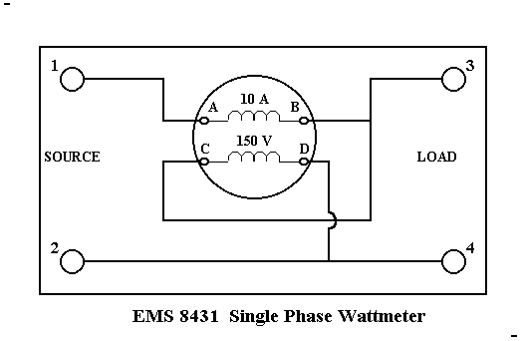

- Using the equipment listed in 2.3.3 above, connect the circuit shown below. Set the resistance module at 57 Ohms.

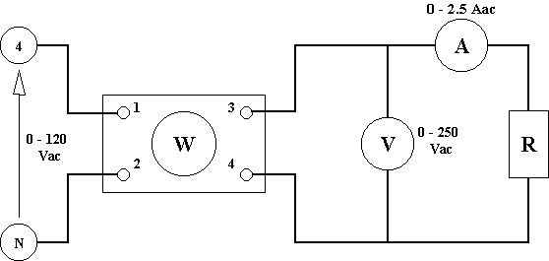 | V ac = 120 V rms  I ac = _______ A rms  P in = _______ W  S = Vac x Iac =_____ VA

- Turn on the power supply and adjust the voltage control until the AC voltmeter reads 120 V rms.

- Measure and record the load current, Iac, from the ammeter and the input power measured by the wattmeter, Pin.

- Calculate the input power using P = VI and record it. Does this value correspond with the value measured by the wattmeter? ________________________

- Remove the load by opening all the switches on all the resistor elements of the resistance module. Note that the wattmeter now reads zero, even though its voltage coil is energized at 120 V rms.

- Return the voltage control knob to zero percent and turn OFF the power supply.

Note: The equation P = VI is the equation for power in DC circuits. In AC circuits, it is the equation for S, the apparent power. Real power is calculated using
P = VI cosθ and is equivalent to the reading from the wattmeter. However, in the case where the load circuit is purely resistive, such as the circuit above, the apparent power, S, is equal to the real power, P. (For the pure resistance case, cos θ = 1)

- Connect the circuit shown below using the Capacitor Module EMS 8331. Wire all three capacitor columns in parallel and turn on all three capacitor elements in each column. This will provide the maximum capacitance available from the module. Note that the circuit is identical to the previous circuit except that a capacitor has taken the place of the resistor.

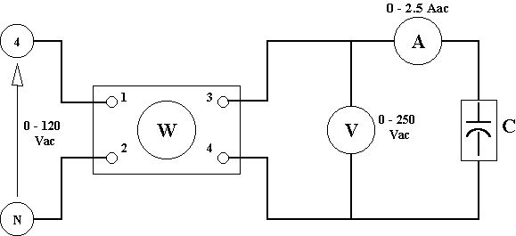 | V ac = 120 V rms  I ac = _______ A rms  P in = _______ W  S = Vac x Iac =_______ VA

- Turn on the power supply and adjust the voltage control for 120 V rms on the AC voltmeter.

- Measure and record the load current, Iac, from the ammeter and the input power measured by the wattmeter, Pin.

- Calculate the input power using P = VI and record it. Does this value correspond with the value measured by the wattmeter? ________________________

(Note that in the case of a purely capacitive load (or nearly so, anyway), the apparent power and real power are quite different.)

- Return the voltage control knob to zero percent and turn OFF the power supply.

- Connect the circuit shown below using the Inductor Module EMS 8321. Wire all three inductor columns in parallel and turn on all three inductor elements in each column. This will provide the minimum inductance available from the module. Note that the circuit is identical to the previous two circuits except that the load is now an inductor.

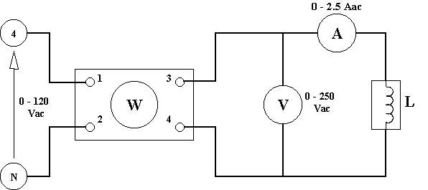 | V ac = 120 V rms  I ac = _______ A rms  P in = _______ W  S = Vac x Iac =_______ VA

- Turn on the power supply and adjust the voltage control for 120 V rms on the AC voltmeter.

- Measure and record the load current, Iac, from the ammeter and the input power measured by the wattmeter, Pin.

- Calculate the input power using P = VI and record it. Does this value correspond with the value measured by the wattmeter? ________________________

(Note that in the case of a purely inductive load, the apparent power and real power are quite different. P should not equal zero, however. A real inductor has inherent resistance due to the impedance of its wire coil.)

- Return the voltage control knob to zero percent and turn OFF the power supply.

- Repeat the experimental procedure used on the last three circuits, for the circuit shown below, where the resistor and capacitor modules are connected in parallel (R = 57 Ohms, C at maximum).

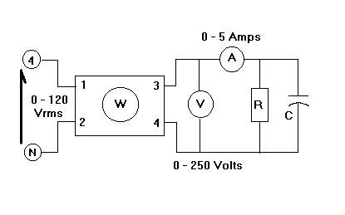 | V ac = 120 V rms  I ac = _______ A rms  P in = _______ W  S = Vac x Iac =_______ VA

    - CONCLUSIONS

- Is a wattmeter required to measure the real power delivered to a purely resistive load? Explain:

______________________________________________________________________

______________________________________________________________________

______________________________________________________________________

______________________________________________________________________

- In what units does one express:

Apparent Power: __________________

Real Power: __________________

- The ratio of real power, P, to apparent power, S, is called the power factor, pf, for the AC circuit and is expressed as the equation, pf = P/S. Calculate the power factor for each of the four circuits analyzed above.

Power Factor, pf = Real Power, P / Apparent Power, S
Resistor | Capacitor | Inductor | R-C
pf = | pf = | pf = | pf =

- Try to name two household devices that should have a high power factor and one device which should have a low power factor.

______________________________________________________________________

______________________________________________________________________

______________________________________________________________________

  - PHASE ANGLE, AC POWER

    - OBJECTIVE

To explore the concept of phase angle and study the relationship between real and apparent power.

    - DISCUSSION

In a DC circuit with a resistive load, an increase in DC voltage level produces a proportional increase in the DC current flowing in the circuit. This is also true in an AC circuit with a purely resistive load. An AC voltage applied to a resistor will produce an AC current whose instantaneous value corresponds directly to the instantaneous value of the voltage. The peak value of the current waveform will occur at exactly the same moment in time as the peak value of the voltage waveform. Likewise, the current zero crossing will occur at the same time as the voltage zero crossing. Such waveforms are said to be in phase. Voltage and current waveforms that are in phase are shown in figure A below:

A. Current and Voltage In Phase
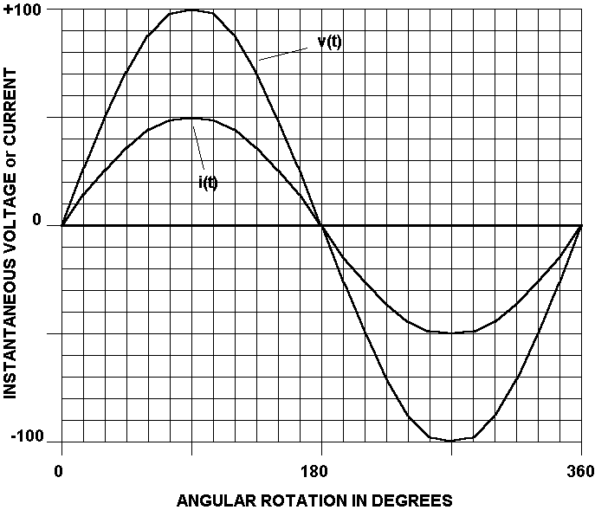

Most AC circuits, however, contain other elements in addition to pure resistances. Under such conditions, the current waveform will not be in phase with the voltage. In an AC circuit where the peak value of the current waveform occurs later in time than the peak of the voltage waveform, the current is said to lag the voltage. Such a condition is shown below in figure B.

B. Current Lags Voltage by 30 Degrees | C. Current Leads Voltage by 30 Degrees
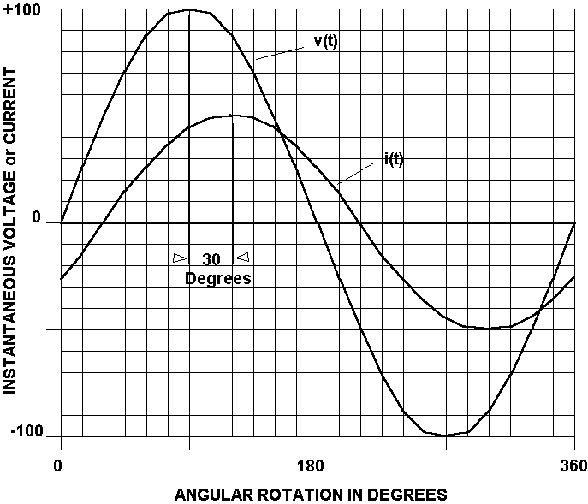 | 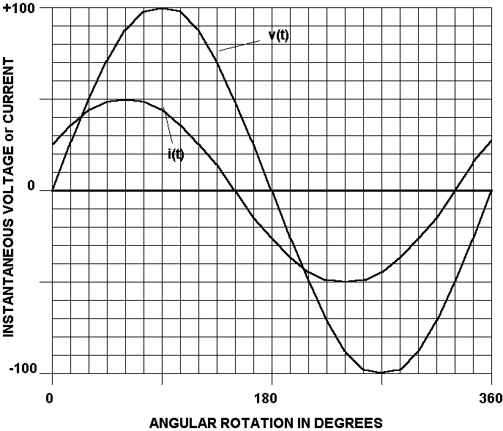

Figure C above depicts a current whose peak value occurs earlier in time than the peak value of the voltage. This current in said to lead the voltage.

It is possible that the current could lead or lag the voltage by as much as 90 electrical degrees (π/2 radians). In figure D below, the current lags the voltage by 90 degrees. It is interesting to note that the current maximum occurs when the voltage is ZERO. Likewise, the voltage maximum occurs at the current zero. Although this seems highly improbable, it occurs because the AC circuit consists of an element which is capable of storing and releasing energy, such as an inductor or capacitor. These elements absorb energy during part of the AC cycle and return it to the circuit later in the cycle. The storing and releasing of energy accounts for the phase angle difference between voltage and current. Loads that are purely inductive will have a current that lags voltage by 90 degrees. Loads that are purely capacitive will have a current that leads voltage by 90 degrees, such as figure E. In either case, a capacitive or inductive load will absorb power for one quarter cycle and then release it all back to the circuit the next quarter cycle. Capacitors and inductors are called reactive elements and as such, dissipate almost no real power.

D. Current Lags Voltage by 90 Degrees | E. Current Leads Voltage by 90 Degrees
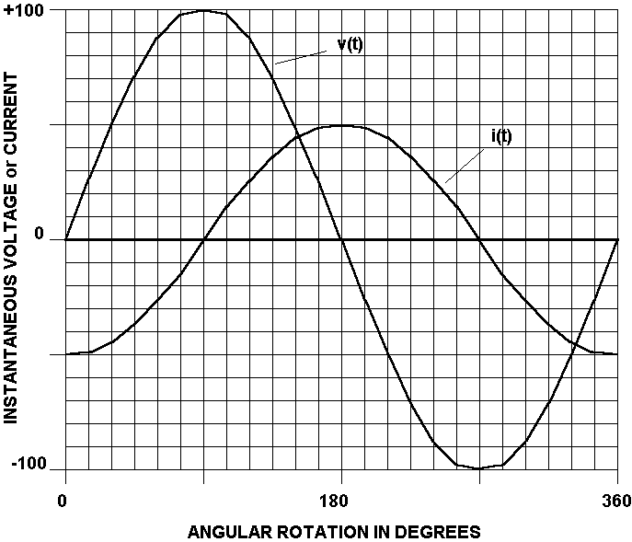 | 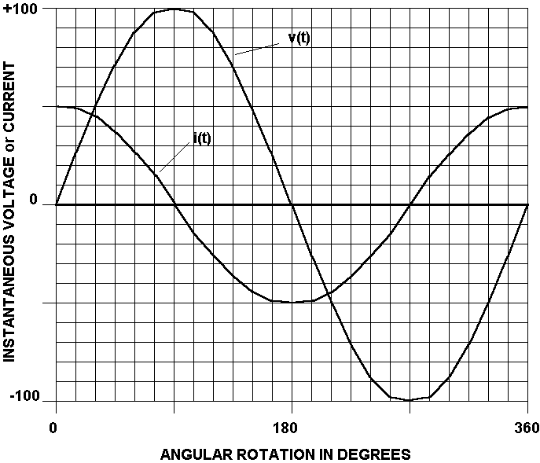

    - INSTRUMENTS AND COMPONENTS (None)

    - PROCEDURE

- The load for the circuit shown below is purely resistive. The AC ammeter reads 35.3 Amps rms and the AC voltmeter reads 70.7 V rms. Calculate the apparent power, S, supplied to the load. (S = VI)

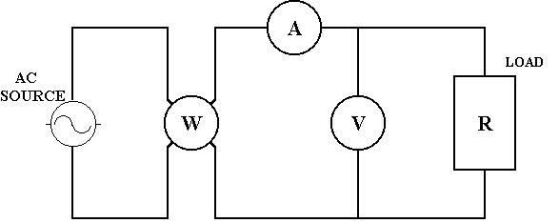 | Vs = 70.7 V rms  Is = 35.3 A rms  S = VsIs = _______ VA

- What should the wattmeter read for this circuit? _________________ Watts

- The voltage and current waveforms for this circuit are shown in figure F below:

F. Instantaneous Current, Voltage and Power for a Resistive Load
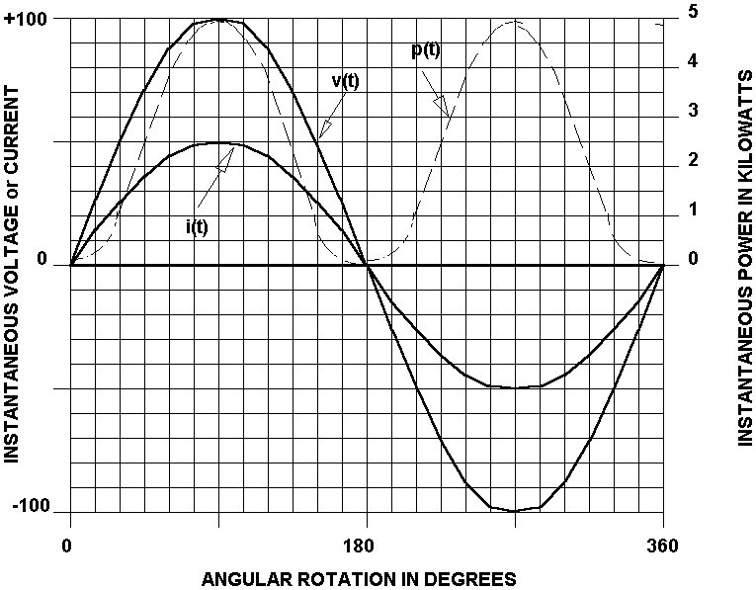

- The instantaneous power, p(t), is also plotted in figure F. Notice that the power waveform is sinusoidal but at double the frequency (two cycles of power per one cycle of voltage or current). Recall the trig identity for SIN²A and answer the following questions:

Does the power curve ever have a negative value for a resistive load? _________

Is the power real? _______________

Write the trigonometric identity which proves that the average power is actually ½ the peak power.

____________________________________________________________________

- The load for the circuit shown below is purely capacitive. The current for this load leads the voltage by 90 degrees, such as in figure E. The AC ammeter still reads 35.3 Amps rms and the AC voltmeter still reads 70.7 V rms. Calculate the apparent power, S, supplied to the load.

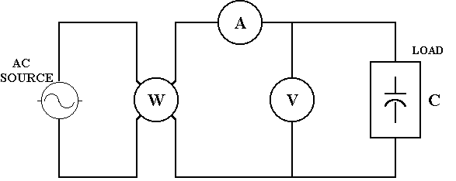 | Vs = 70.7 V rms  Is = 35.3 A rms  S = VsIs = _______ VA

- Should the wattmeter indicate the same power? ___________________

- The voltage and current waveforms for this circuit are shown in figure G below. Notice that the current maximum occurs at a voltage zero and vice-versa.

G. Current Leads Voltage by 90° (Capacitive)
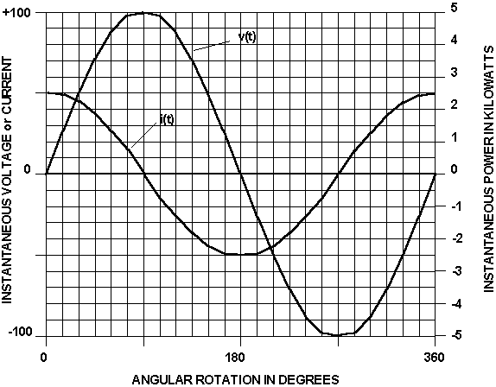

- The following table contains v(t) and i(t) values at 45 degree intervals. Complete the table by calculating the instantaneous power, p(t) = v(t)i(t) VA at each interval.

Degree | 0 | 45 | 90 | 135 | 180 | 225 | 270 | 315 | 360
v(t) | 0 | 70.7 | 100 | 70.7 | 0 | -70.7 | -100 | -70.7 | 0
i(t) | 50 | 35.3 | 0 | -35.3 | -50 | -35.3 | 0 | 35.3 | 50
p(t)

- Plot the calculated values of p(t) on the graph in figure G and draw a smooth curve connecting the points. Remember that the power curve will be sinusoidal at twice the frequency of the voltage and current.

- Determine the following information from the power curve:

Peak power = _______________VA, at ____________ degrees

Is the instantaneous power ever negative? ___________

Are all the peaks of the power curve of the same magnitude? ___________

Does the area enclosed under the positive portions of the curve equal the area enclosed under the negative portions of the curve? _______________

The average or real power for one complete cycle (360 degrees) must be _________ W.

- The load for the circuit shown below is purely inductive. The current for this load lags the voltage by 90 degrees, such as in figure D. The AC ammeter still reads 35.3 Amps rms and the AC voltmeter still reads 70.7 V rms. Calculate the apparent power, S, supplied to the load.

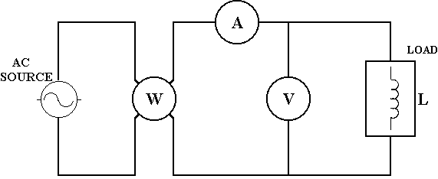 | Vs = 70.7 V rms  Is = 35.3 A rms  S = VsIs = _______ VA

- Should the wattmeter indicate the same power? ___________________

- The voltage and current waveforms for this circuit are shown in figure H below. Notice that the current maximum occurs at a voltage zero and vice-versa.

H. Current lags Voltage by 90° (Inductive)
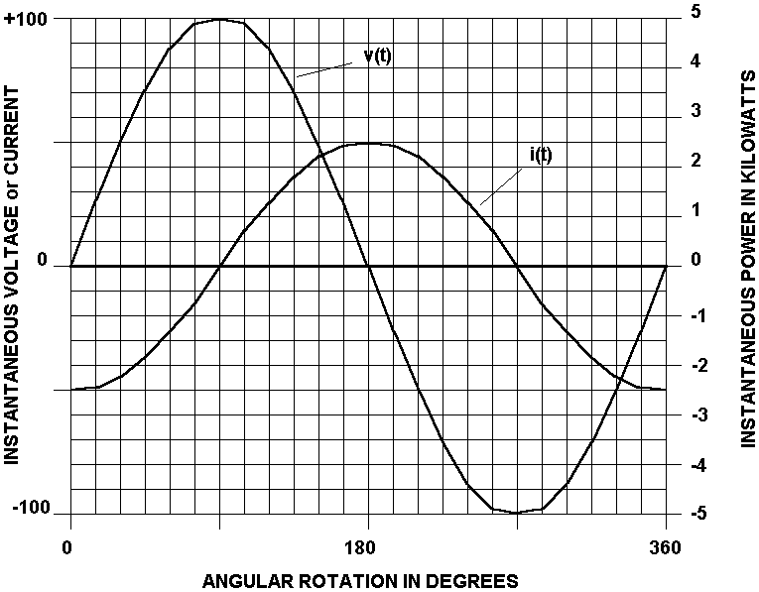

- The following table contains v(t) and i(t) values at 45 degree intervals. Complete the table by calculating the instantaneous power, p(t) = v(t)i(t) VA at each interval.

Degree | 0 | 45 | 90 | 135 | 180 | 225 | 270 | 315 | 360
v(t) | 0 | 70.7 | 100 | 70.7 | 0 | -70.7 | -100 | -70.7 | 0
i(t) | -50 | -35.3 | 0 | 35.3 | 50 | 35.3 | 0 | -35.3 | -50
p(t)

- Plot the calculated values of p(t) on the graph in figure H and draw a smooth curve connecting the points. Remember that the power curve will be sinusoidal at twice the frequency of the voltage and current.

- Determine the following information from the power curve:

Peak power = _______________VA, at ______ and ______ degrees

Is the instantaneous power ever negative? ___________

Are all the peaks of the power curve of the same magnitude? ___________

Does the area enclosed under the positive portions of the curve equal the area enclosed under the negative portions of the curve? _______________

- The average or real power for one complete cycle (360 degrees) must be _________ W
    - CONCLUSIONS

- If in one complete cycle, the instantaneous power, p(t), is always positive, then the load

must be a pure __________________.

- In the space below, make a rough sketch of a current waveform lagging a voltage waveform by 60 degrees.

- A wattmeter reads zero watts when the current lags or leads the voltage by 90 degrees. Explain this phenomenon.

______________________________________________________________________

______________________________________________________________________

______________________________________________________________________

______________________________________________________________________

- In a 60 Hz system, if the current leads the voltage by 45 degrees, what is the time difference, in milliseconds, between the occurrence of each respective peak?

______________________________________________________________________

______________________________________________________________________

______________________________________________________________________

______________________________________________________________________

